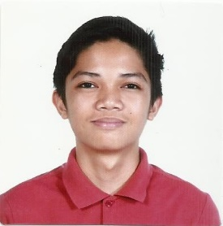

David Warren I. Arcellana

245 Teachers Bliss Kalayaan Village, Pasay City

09174840904

diarcellana@student.apc.edu.ph

**EDUCATION**

**Tertiary**

**2013-2017: Asia Pacific College, 3 Humabon Place, Magallanes, Makati City**

* Bachelor of Science in Information Technology Major in Mobile and Internet Technology
* Year of Graduation: 2017
* Relevant Coursework: Web & Mobile Application Developer, Networking, Database Designer

**Secondary**

**2009-2013: Sta. Clara Parish School. Pasay City**

**SKILLS AND INTERESTS**

* Typing, Drawing (using Illustrator), Editing (using Photoshop and other editing apps)
* Web Application Developing through HTML5, PHP, JavaScript, Python Programming using Django Framework
* Android Application Developing through Java Programming
* Play sports game, Watching movies, Traveling,

**REFERENCES**

* Ms. Arwena Manuel

Fourth Year High School Adviser and IT subjects Teacher

Sta.Clara Parish School

* Mr. Manuel Sanchez

College Professor, Project-Based Learning Professor and Adviser

Asia Pacific College